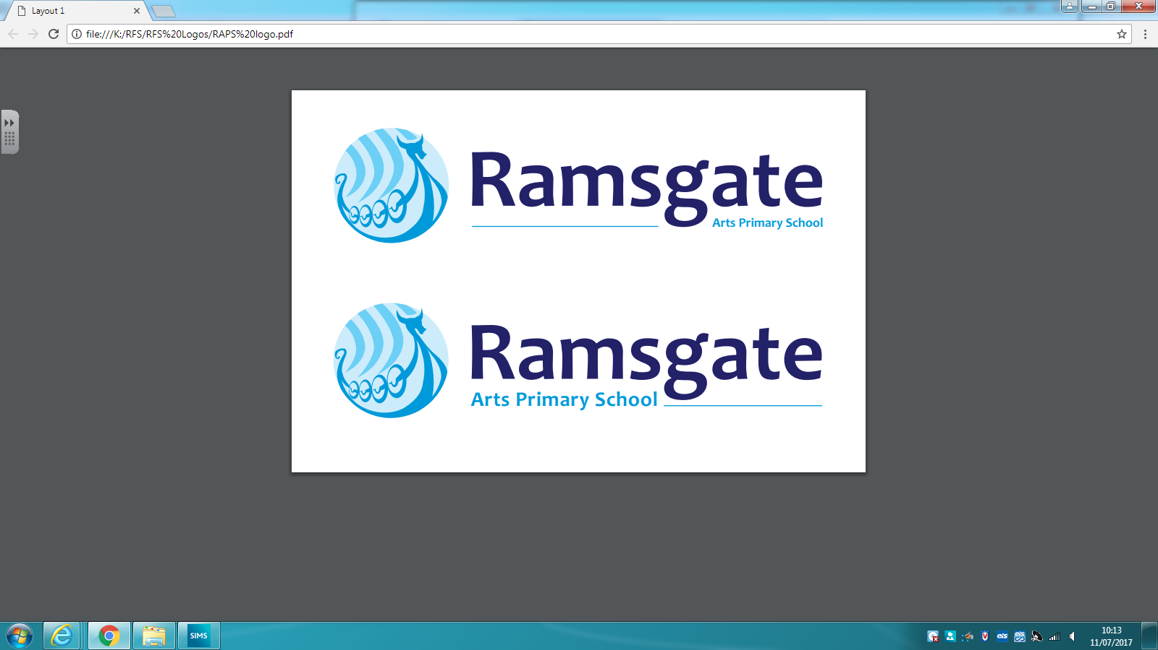

140-144 Newington Road Ramsgate, CT12 6PT
Dover Museum 13th February 2020
Dear parents/carers,
To support our learning in our topic ‘Invaders and Settlers’, Year 6 will be visiting Dover Museum on 13th February. We will be leaving school around 9.15am and will return so the children are ready to be collected at normal time (4.15pm).
During our visit, we will have an introductory talk where we will see and learn about a Bronze Age boat, an art workshop where we will make a clay Sutton Hoo mask and a drama workshop on the Anglo Saxon invasion.
There will also be some time for shopping at the gift shop so children may bring a maximum of £5 to spend and must be responsible for their own money.
Children will also need to bring a packed lunch and drinks (no fizzy drinks please).
The cost of the trip is £9.50 per child, which includes their train ticket. Please make the payment online and return the attached form by 31st January 2020.
Parents are more than welcome to join us. You can meet us there or take the train with us (you will need to buy yourself a train ticket).
Kind regards,
Miss Dannell
--------------------------------------------------------------------------------------------------------------------------
Team Dannell- Dover Museum 13th Feb 2020

I ______________________ parent/carer of ___________________________ give permission for my son/daughter to attend Dover Museum on 13th February and to receive emergency medical treatment if necessary.

Signed _____________________________ Date ___________________-

