Love to Learn
This week we have been learning about the Saxons and in particular answering the question: ‘Did the Saxons like Art?’
We discovered that, yes; they did seem to like art as we learnt about the some of the artefacts that have been found by archaeologists.
These included:
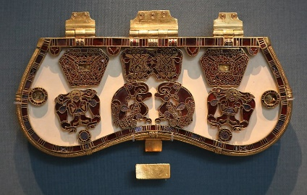
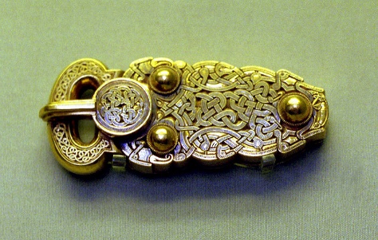
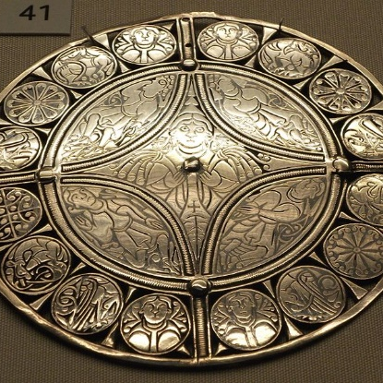
A purse lid
The Great Buckle
Metalwork art

Glassware
Stone sculpture and carvings
The Alfred Jewel
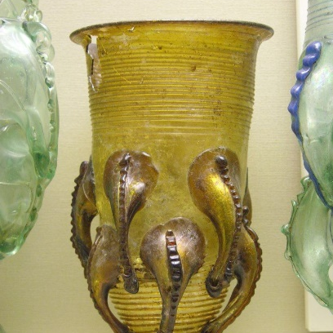
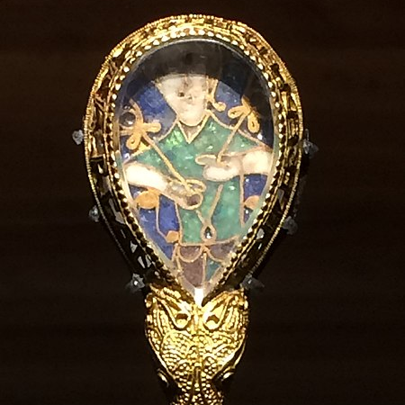


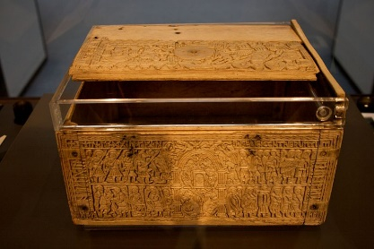
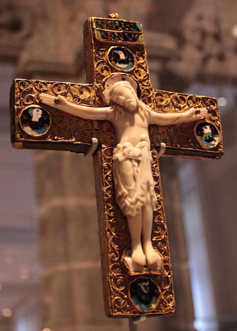
Ivory and bone carving
Tapestry
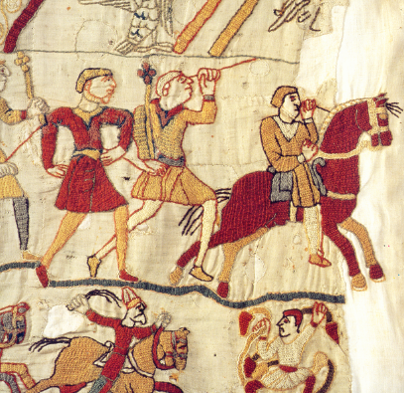

Your love to learn is to create your own Saxon-style piece of art. It doesn’t have to be made using the same materials as the original artefacts! Just try and make your own replica version.

You could:
- Use clay/playdough to create a ‘carving’ or sculpture
- Design your own brooch pattern on the computer or using tin foil
- Make your own jewel using tissue paper
- Design your own tapestry using cross stitch
- Design your own purse lid on paper or card
If you want to learn more about the artefacts, visit the blog and read the PowerPoint.
You should bring in your finished pieces by Friday 14th February to share with the class.
Good luck!

