

TEAM AMIN: LOVE TO LEARN

Due: by the start of Term 5
This term, we are exploring plants!
To encourage you to get in touch with your green sides or your green fingers (which have certainly been proven this week with your beans), I am asking you to carry out your own plant enquiry at home!
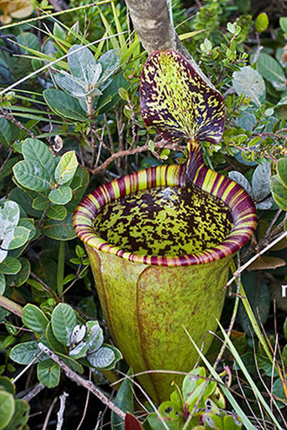
Your enquiry and method is up to you. You could grow plants or research online. Some questions you might explore include:
What is the tallest plant in the world?
Do plants grow better in the sunlight or in the shade?
Which continent has the most types of plants? Name some of these plants.
What species of plants can be found underwater and what are they like?
NOTE: You will need to observe a plant you already have growing or plant your own seeds in soil at home and watch the plant’s growth if you are following an investigation question.
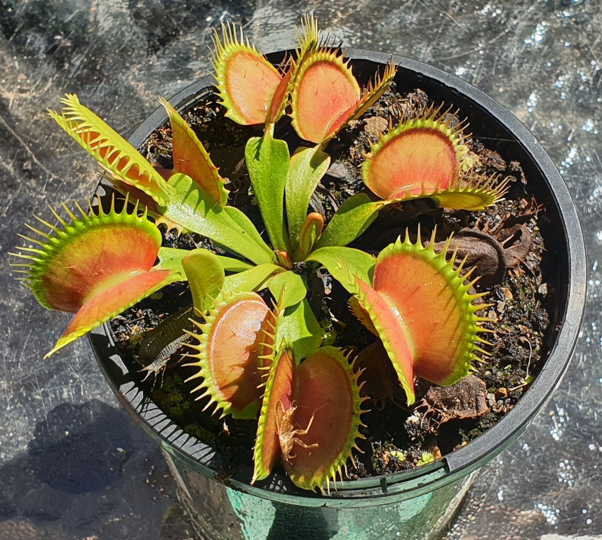
Please do complete your L2L. It is an important part of the learning journey and really deepens children’s interactions with the world.

