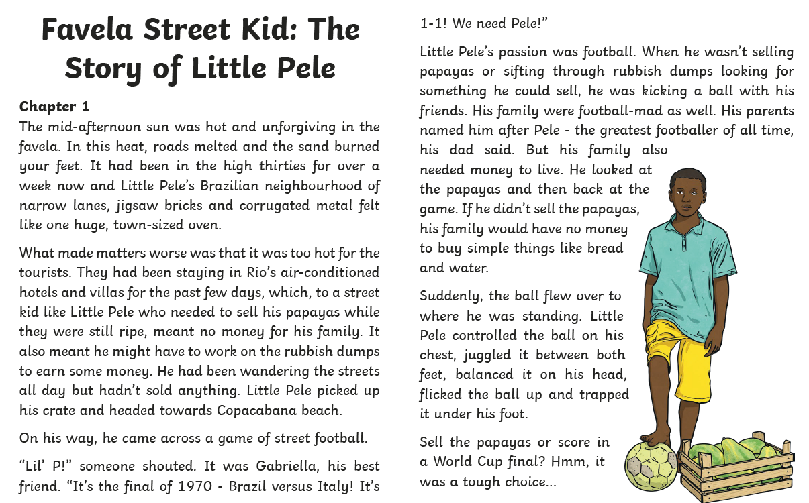
Answer these questions in your exercise book. (You don’t need to write the question).
- What is a ‘favela’? (1 mark)
- Why was there no money coming in for Little Pele’s family? (1 mark)
- Name 2 ways in which Little Pele makes money (2 marks)
- Why do you think Little Pele was heading to the beach? (1 mark)
- At the end Little Pele has to make a choice: sell the papayas or score a goal. What do you think he will do? Why? Use evidence from the text (2 marks)
- What does this chapter tell you about Little Pele’s character? Explain 2 features of his character using evidence from the text (3 marks)

