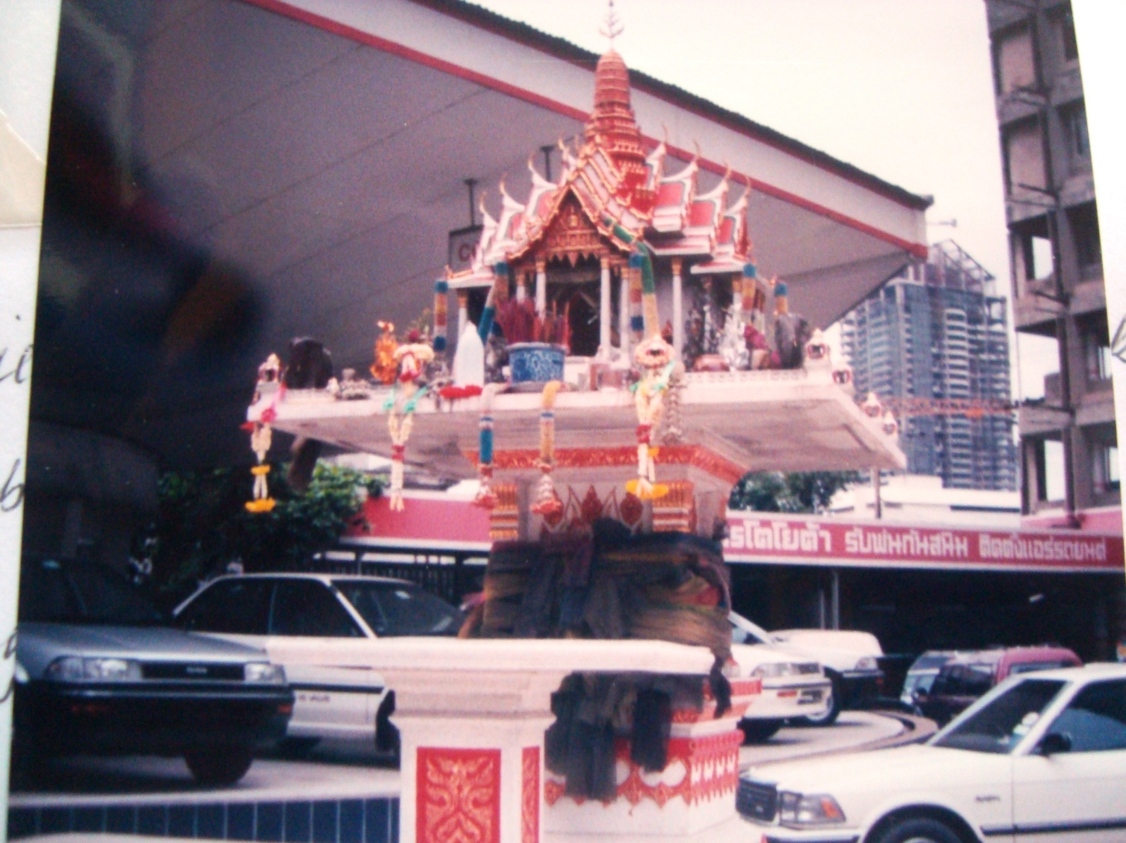

Street shrine outside a garage
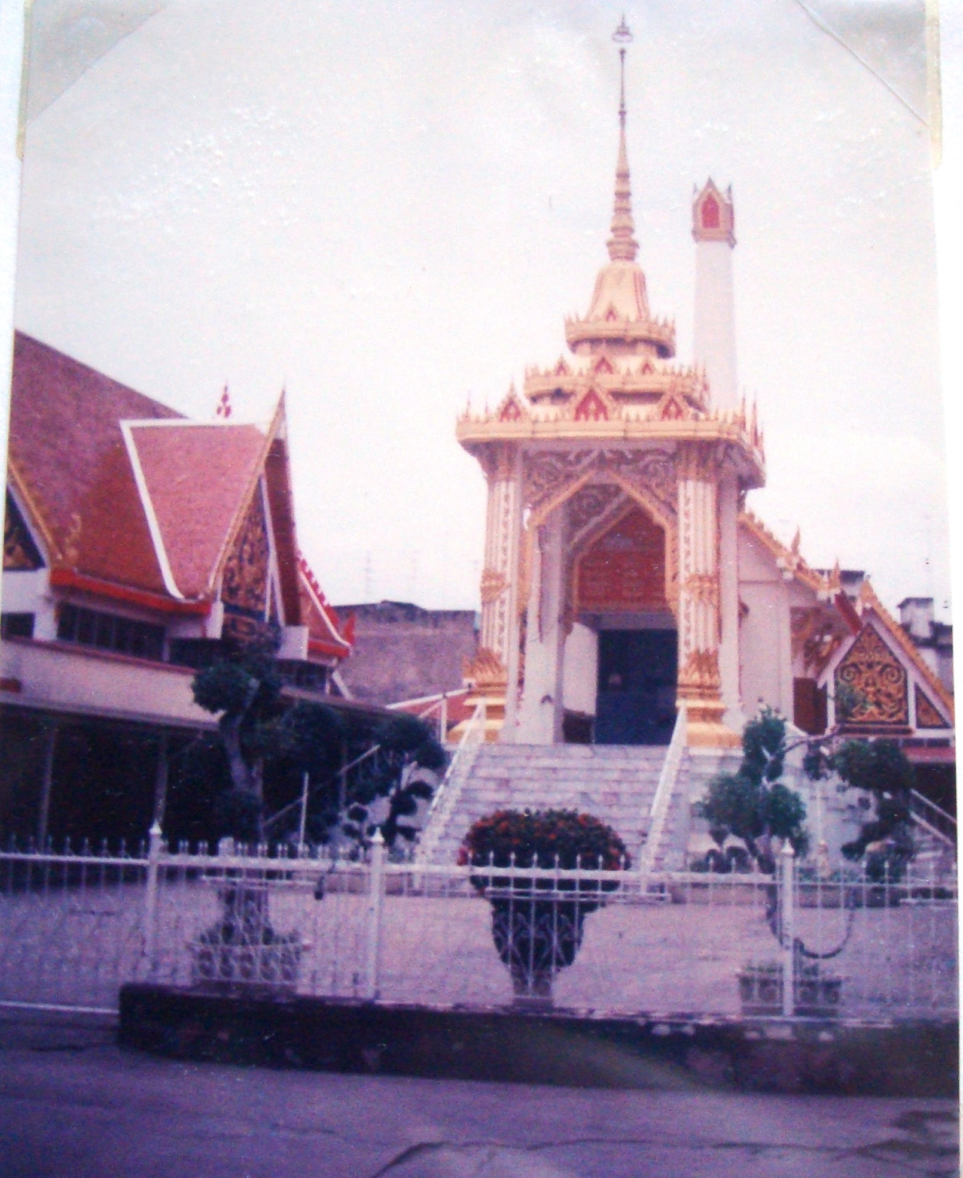
Wat on Rama IV Road
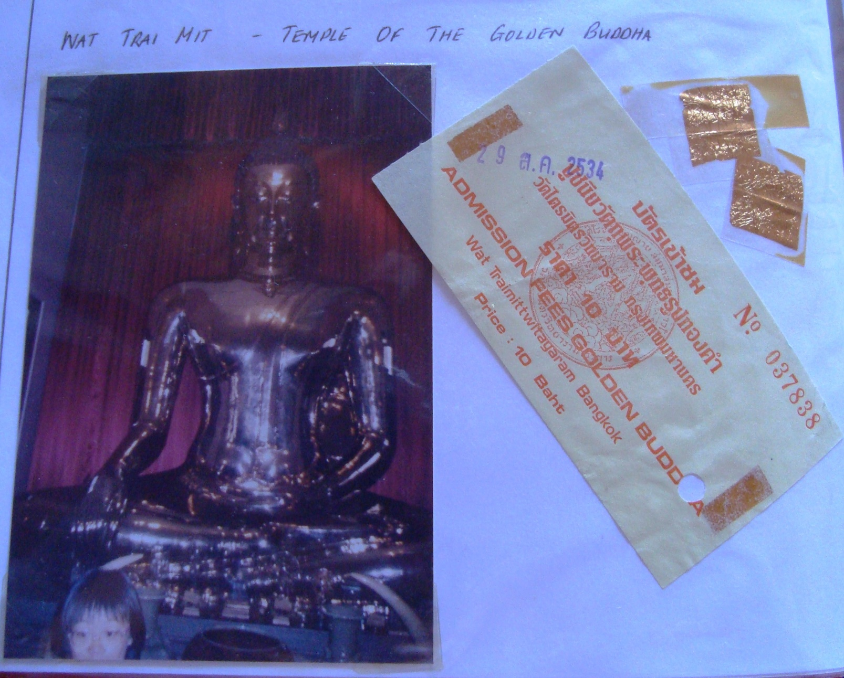

Wat Trai Mit – Temple of the Golden Buddha. You buy small pieces of gold leaf to attach to the statue as you pray.
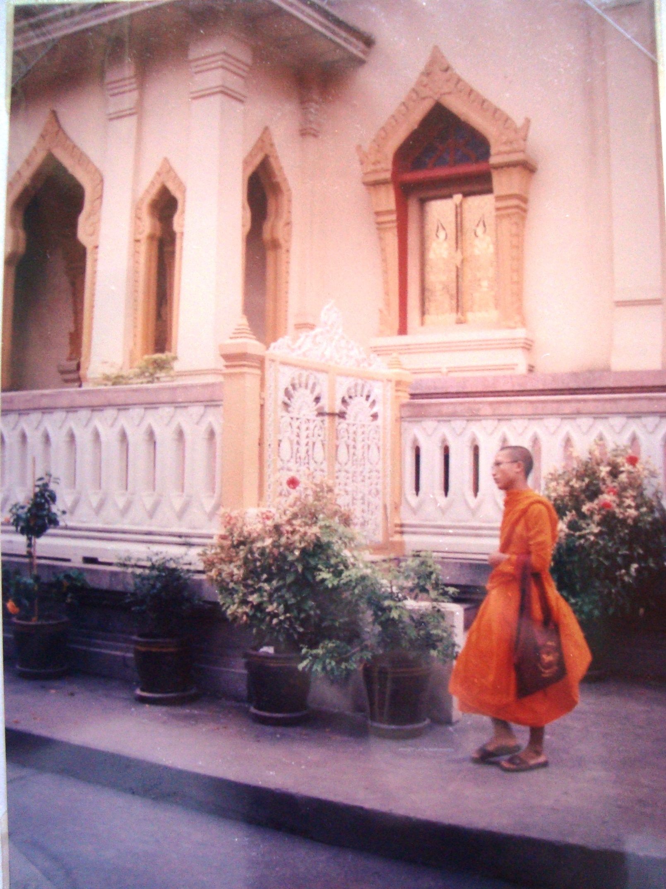
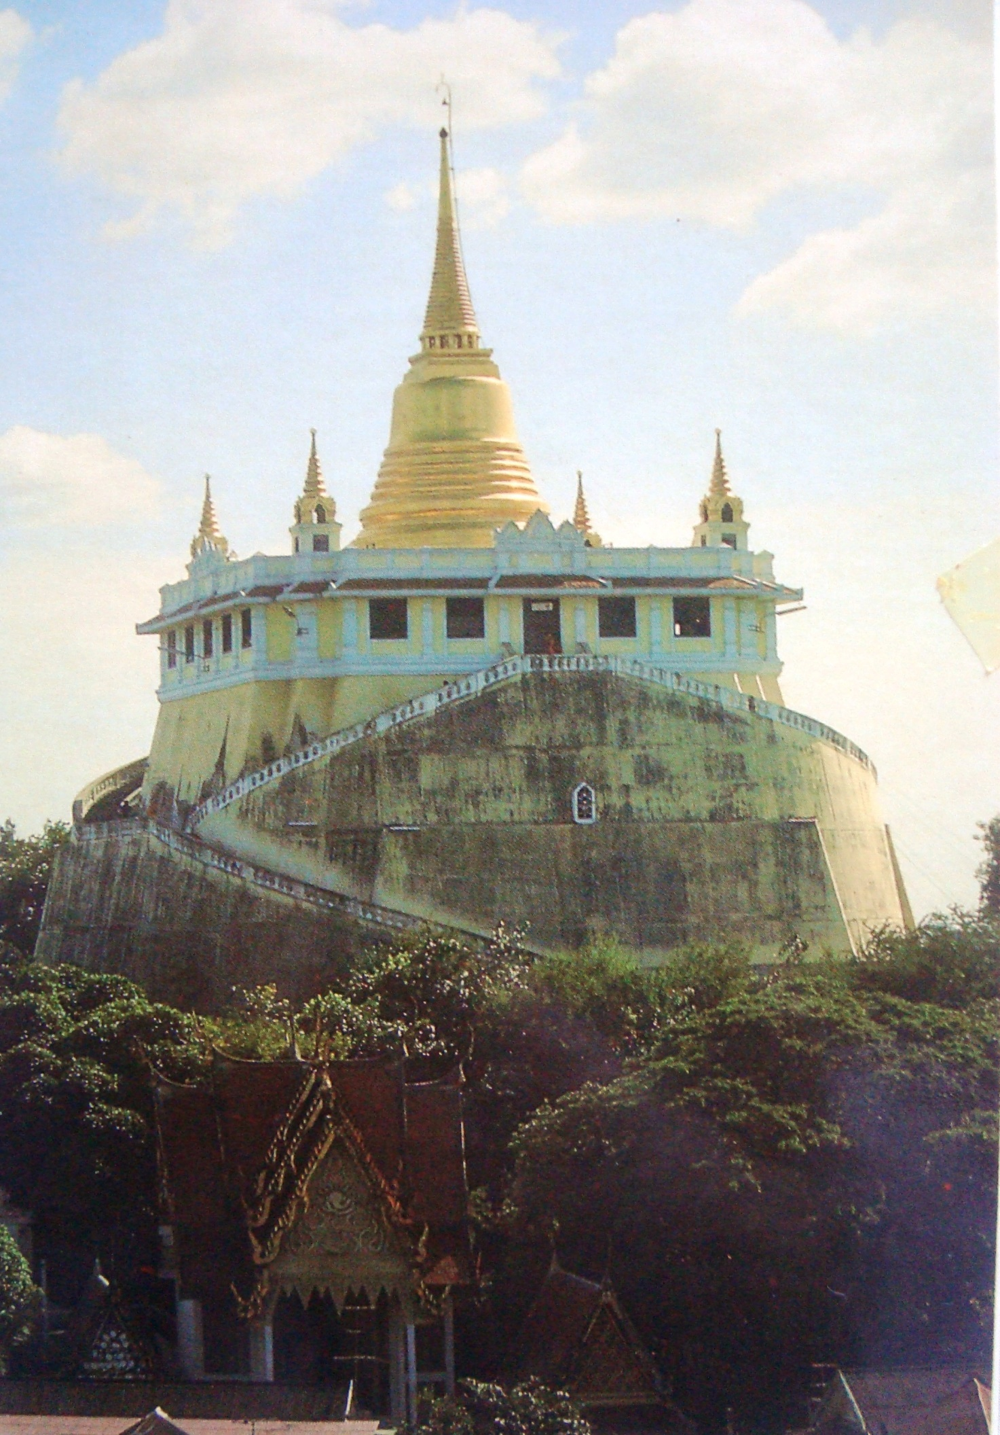

The Temple at The Golden Mount – built by subscription. All those who donated have small shrines at the bottom. The actual mountain is man-made.
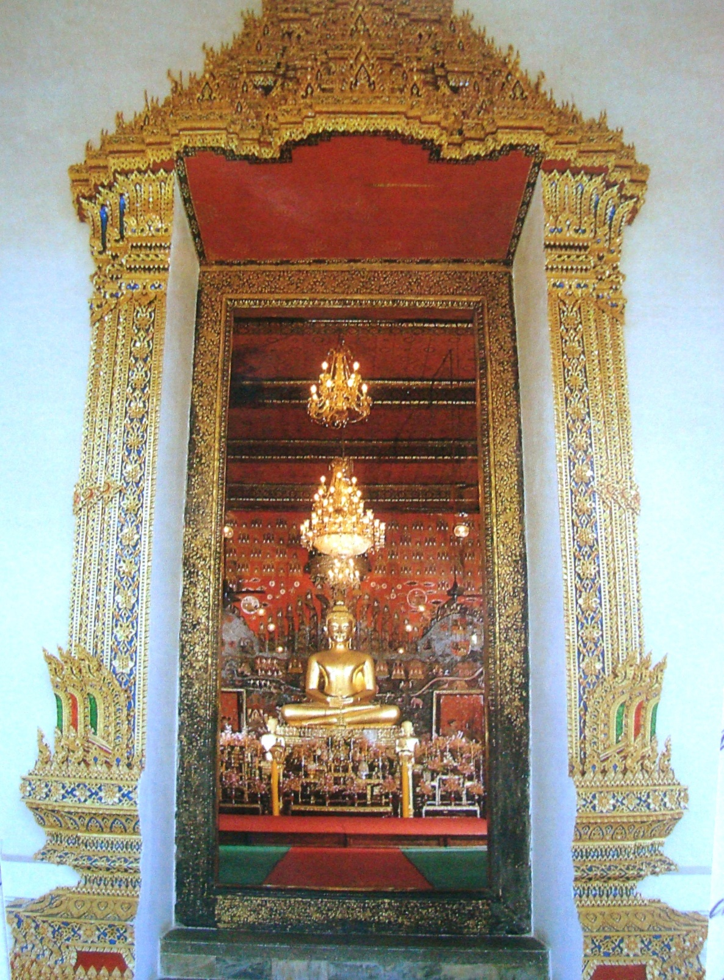

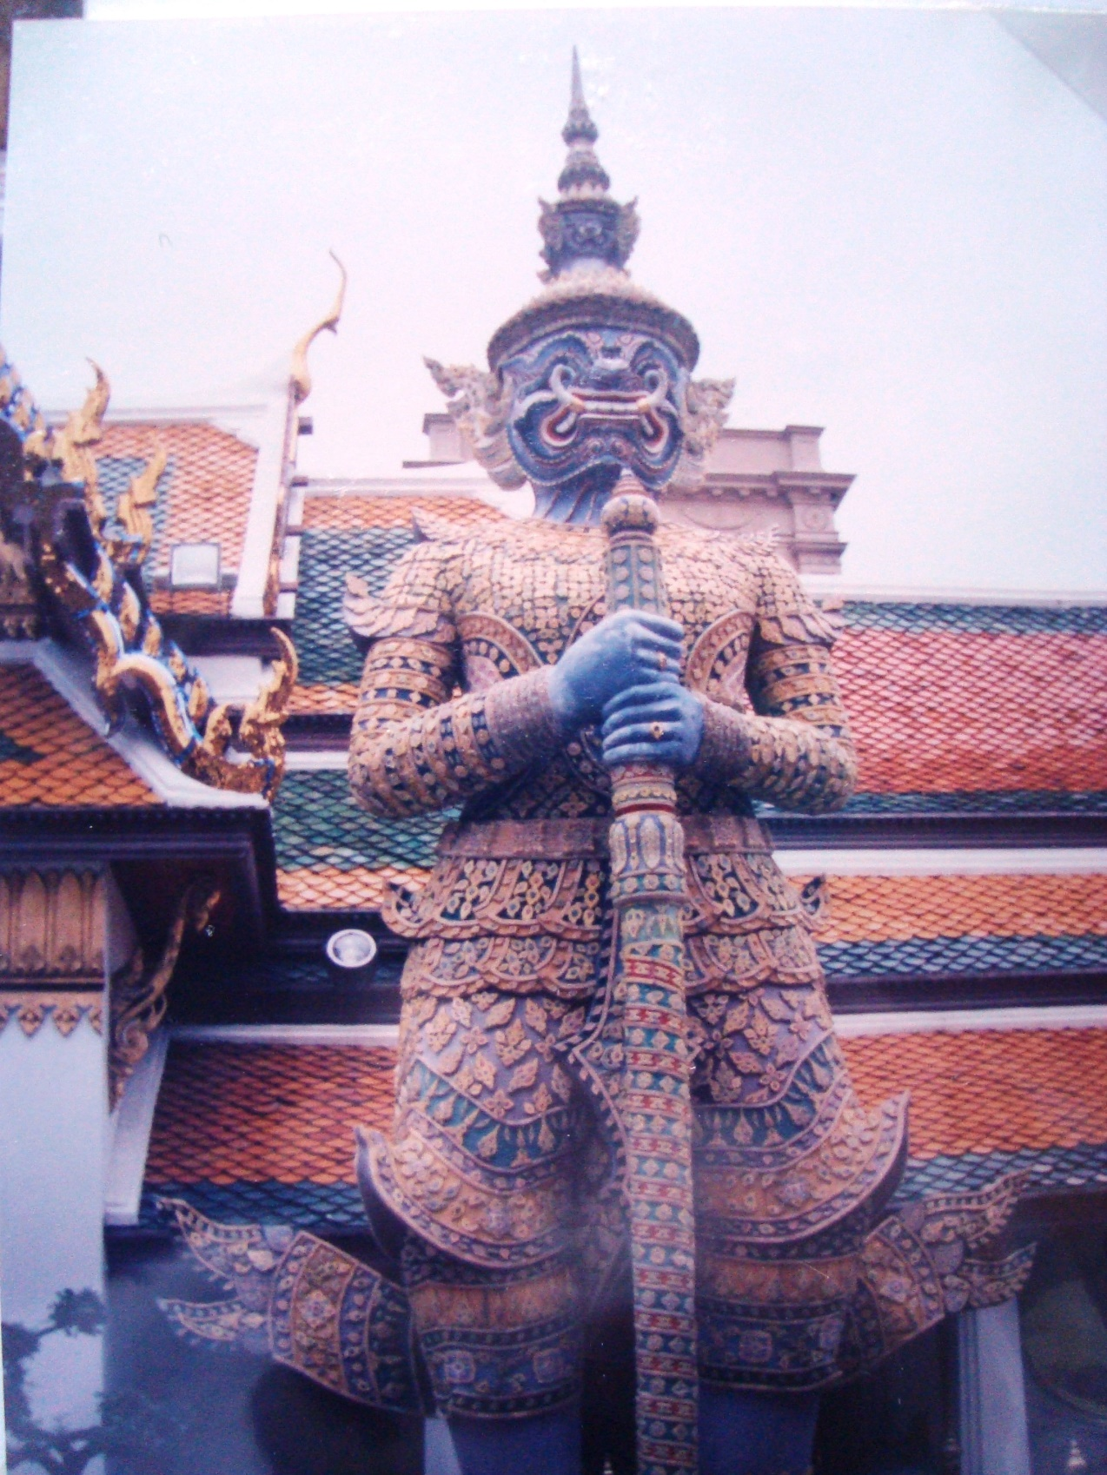

The devil is looking away from the temple so is protecting it. If it was facing the temple it would be a bad devil.
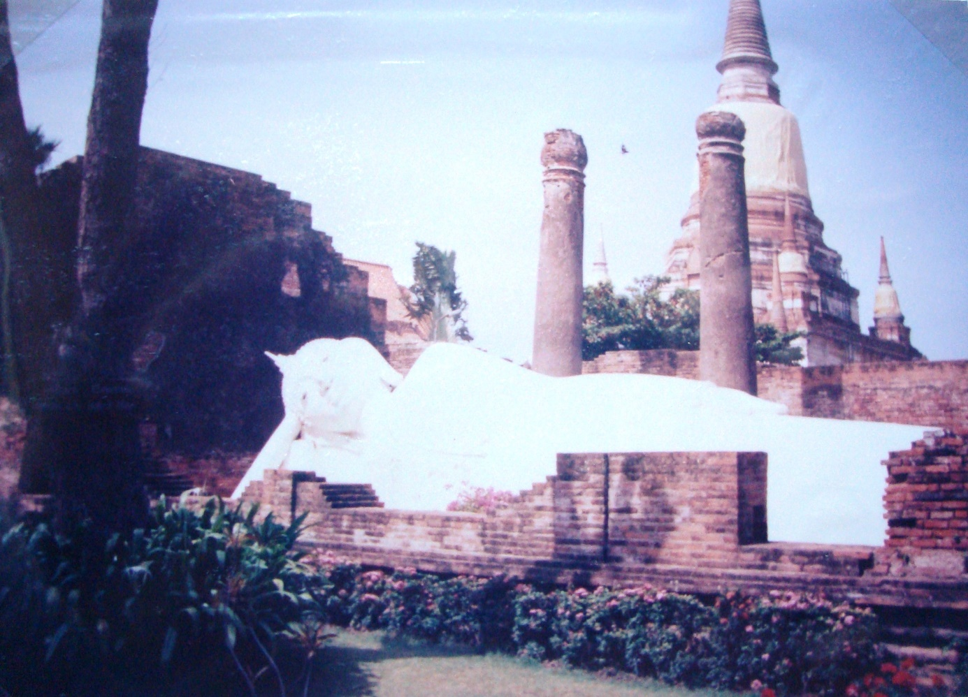
The reclining Buddha at the Wat at Ayutthaya – the 2nd capital of Thailand
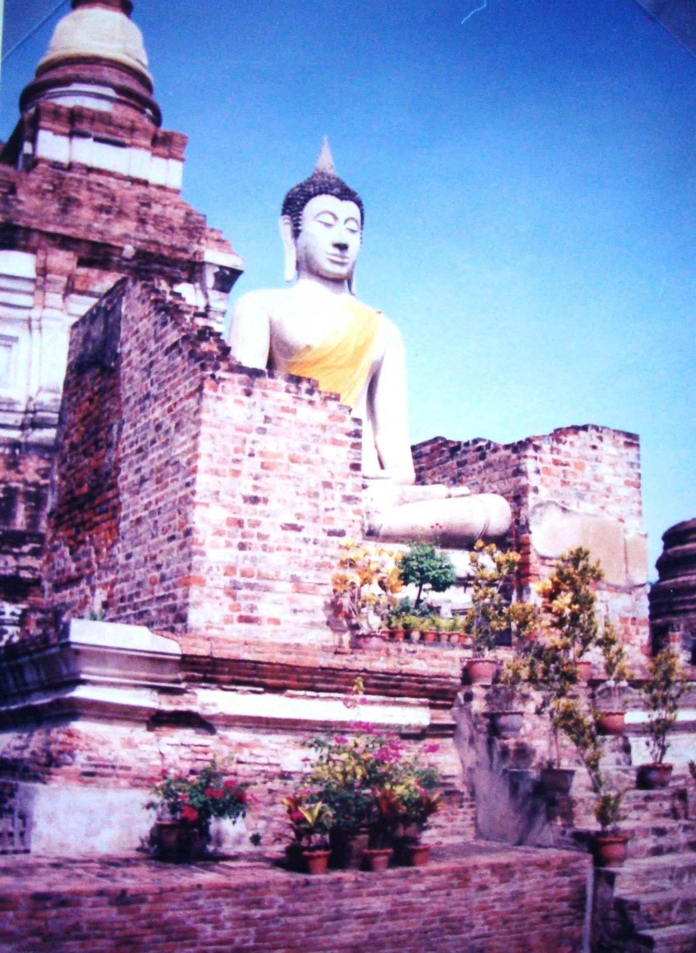
The Buddha wear different colour shawls during the year – this is the summer dress.

