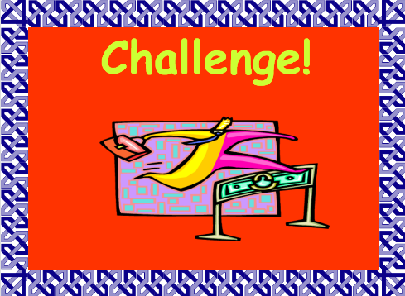
Shade a fraction, then write the fraction in the red box.
Shade a fraction, then write the fraction in the red box.

