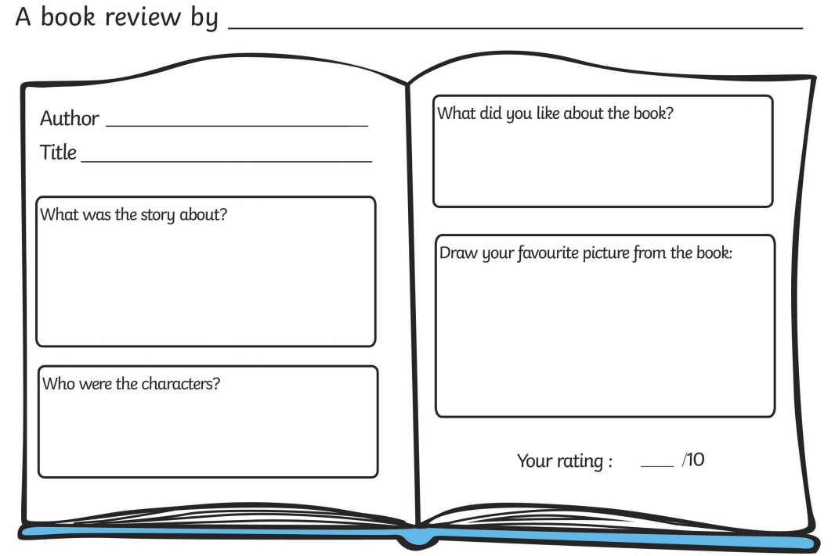

Too few

Too many

Just right

Too hard

Just right

Too easy

What did you think about? (please tick)

Word difficulty:

Illustrations:

What wasthe book **about**? (Key events)

_________________________________________________________________________________________________________________________________________________________________________________________________________________________________________________________

**Who** else might like this book? ***WHY?***

***__________________________________________________________________________________________________________________***

Your rating:

What **didn’t** you like about the book?

____________________________________________________________________________________________________________________________________________________________________________

What **did** you like about the book?

___________________________________________________________________________________________________________________________________________________________________________