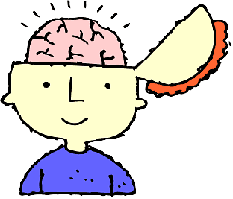
YEAR 3: LOVE TO LEARN

!!
Due by: Monday 23rd May 2022
This term, Year 3’s RAPS Curriculum topic is all about PLANTS, with a focus on identifying parts of a plant, their functions and, of course, investigating their growth! To immerse the children further in our unit, here is their Love to Learn! Please select 1 or 2 of the following tasks to complete:
- Keep a plant diary for the spider plants (sent home in Week 1). If you don’t have your spider plant anymore, you could use another plant in your house or garden!
- Grow something of your own at home! Perhaps you might like to grow sunflowers, tomatoes or…. peas!
- Create some artwork inspired by or using plants! You could do a leaf rubbing, a collage, a painting! Maybe you could press some flowers?
- Use your English learning to plan and create your own comic strip including a monstrous plant (e.g. a Venus flytrap) as a main character!
