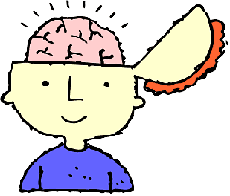
TEAM AMIN: LOVE TO LEARN

Due week beginning: Monday 22nd April 2019 (by Thursday)
This term, Team Amin’s RAPS Curriculum topics, ‘Life all around us’ and ‘Sound’, offer various projects that the children might like to work on, especially over the holiday. They have several potential choices but are welcome to do something completely different if they would like to and are able to explain it! They can work independently or in groups.
Life all around us
- Create your own classification key of living things around you (plants, animals, people)
- Invertebrate inspired artwork (echinoderm, protozoa etc.)
- Create your own documentary exploring the world around us (favourite animals, crazy plants, climate change etc.)

Sound
- Make your own piece of music exploring volume, pitch etc.
- Create your own information guide for sound (including key vocabulary and definitions)
- Make a model ear (papier mache, clay etc.)

This project needs to be in the week back after the Easter holidays.

