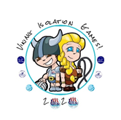

Team RAPS,

The pictures and videos that you are sending in are fabulous, thank you.

This week we continue to challenge you in Olympic events!

You will be an Olympian! Choose your country and participate in the event using your imagination! I cannot wait for these pictures and videos.

The Olympic Challenges this week are:
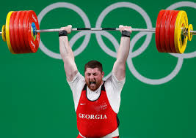
Weightlifting

https://tokyo2020.org/en/news/videos/one-minute-one-sport-weightlifiting

Baseball

https://tokyo2020.org/en/news/videos/one-minute-one-sport-baseball

Have a look at the links to give you some ideas!

Good luck!

Please continue to send them to jenny.horrigan@ramsgateartsprimaryschool.co.uk

Mrs Horrigan

