- 2984 + 591 = | - What is 263 X 2?
- What numbers are missing?  65, _____ , 77, 83, _____ , 95, _____ , _____ , _____ | 4. Put in the appropriate sign ( < > = ):  8.8 [ ] 8.08  5 and a half [ ] 5.2  10110 [ ] 10101
5. Round to the nearest 10:  15 –  948 – | 6. Circle all of the even numbers:  8 4 17 3 106  213 465 1058 1571
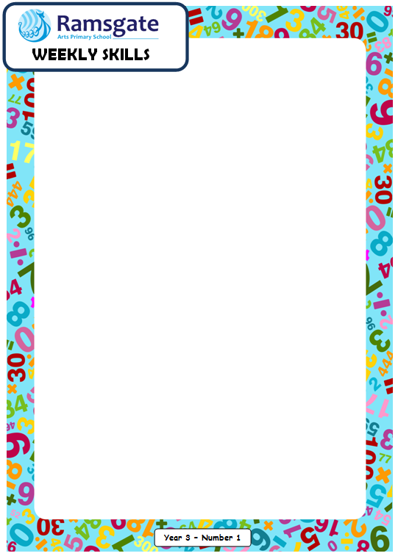
Date: ___________________

7. Find the difference between 718 and 3000. | 8. What is 657 divided by 3?
9. Draw an array of 3 by 4 and write out the relevant number sentences.
Year 4

Date: ___________________

Year 4
- Find the product of 185 and 3. | 11. Put in the appropriate sign:  7 lots of 1 [ ] 8  6 lots of 4 [ ] 3 lots of 8
12. What is 100 MORE than:  a) 256  b) 979 | 13. What is 100 LESS than:  a) 1647  b) 1009
14. Mrs Fox bought 9762 cupcakes and shared them between herself, Miss Amin and Mrs Ivan. How many cupcakes did each adult get? Will there be any left over?

15.  a)  b)  c) | Order from smallest to greatest  133 331 313 131 333  4827 4287 8724 8427 3274  0.39 0.44 0.37 0.34 0.27
Year 4

