Read Write Inc Gang Monday 13th – Friday 17th July 2020
It is the final week of school for most of us. What a strange couple of terms it has been with home schooling, keeping safe and do I wear a face mask or not?
I hope you are all still taking care of yourselves and your families. Please feel free to email me any time during the summer holidays if there is anything I can do for you. rachel.fox@ramsgateartsprimaryschool.co.uk
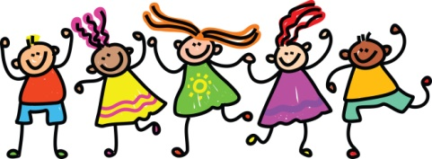
We have virtually reached the end of our Blue level books so, for a change I thought I would send you a few fun tasks to do.

1. | Write out your name in full (e.g. Rebecca Isabelle White) and see how many words you can make using the letters in your name.
2. | Draw and label a new school uniform and badge for the children in your own home school to wear.
3. | Choose a subject that makes you go “wow” such as animals, food, TV programmes or sport and see if you can think of one for every letter of the alphabet.
4. | Write about the job you would like to do when you are an adult. What is it called? Do you need training? What would you wear? Where would you work? Why did you choose that job? Draw a picture of you in that role.
5. | Imagine that I have sent you a stone that gives you 3 wishes. What would you wish for and why?
6. | Write me an acrostic poem based on your name.  Mine might say:  My job is always fun. I  Really enjoy working with the very  Smart children in my group.  Flowers make me smile but  Only when the sun is out.  X is an impossible letter!
7. | Can you write me a story telling me who this is and what they are doing?  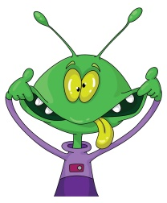
8. | You might need to help this alien if they come and live in Ramsgate so could you tell them a bit about the area we live in – the beach, the shops, swimming pools, cafes, mini-golf and all the other things you like to do. Tell them about the weather, the people who live here and why you like it.
9. | Now tell me what you would like to do in the summer holidays to cheer your selves up. Not imagination this time but all the real things you have missed being able to do during lock down.
10 | And then finally, tell me what you would like to do when we get back to school. Should the lessons be a bit different? Who would come in and when? Who would you like to be your teacher? Which classroom would you like to be in? Would you like to learn things we haven’t learned yet in school?

Plenty to choose from! Send me your work so I can see what ideas you have (and I might even pass a few onto Mr Budge!)
Finally, have a great holiday and see you in September if I don’t spot you in school next week for the picnics.
Big air hugs and kisses to you all from 